Title of project

Rupert Claisse

**BEng (Hons) in Software and Electronic Engineering**

**Project Engineering**

# Ben Kinsella

Atlantic Technological University Galway

I plan to design a board to connect an ESP32 microcontroller to a secondary board that provides both a physical and an electrical connection to each other. In addition, I plan to route all of the connections on these boards to one side of the new board, in order to simplify any potential future installation into another device.

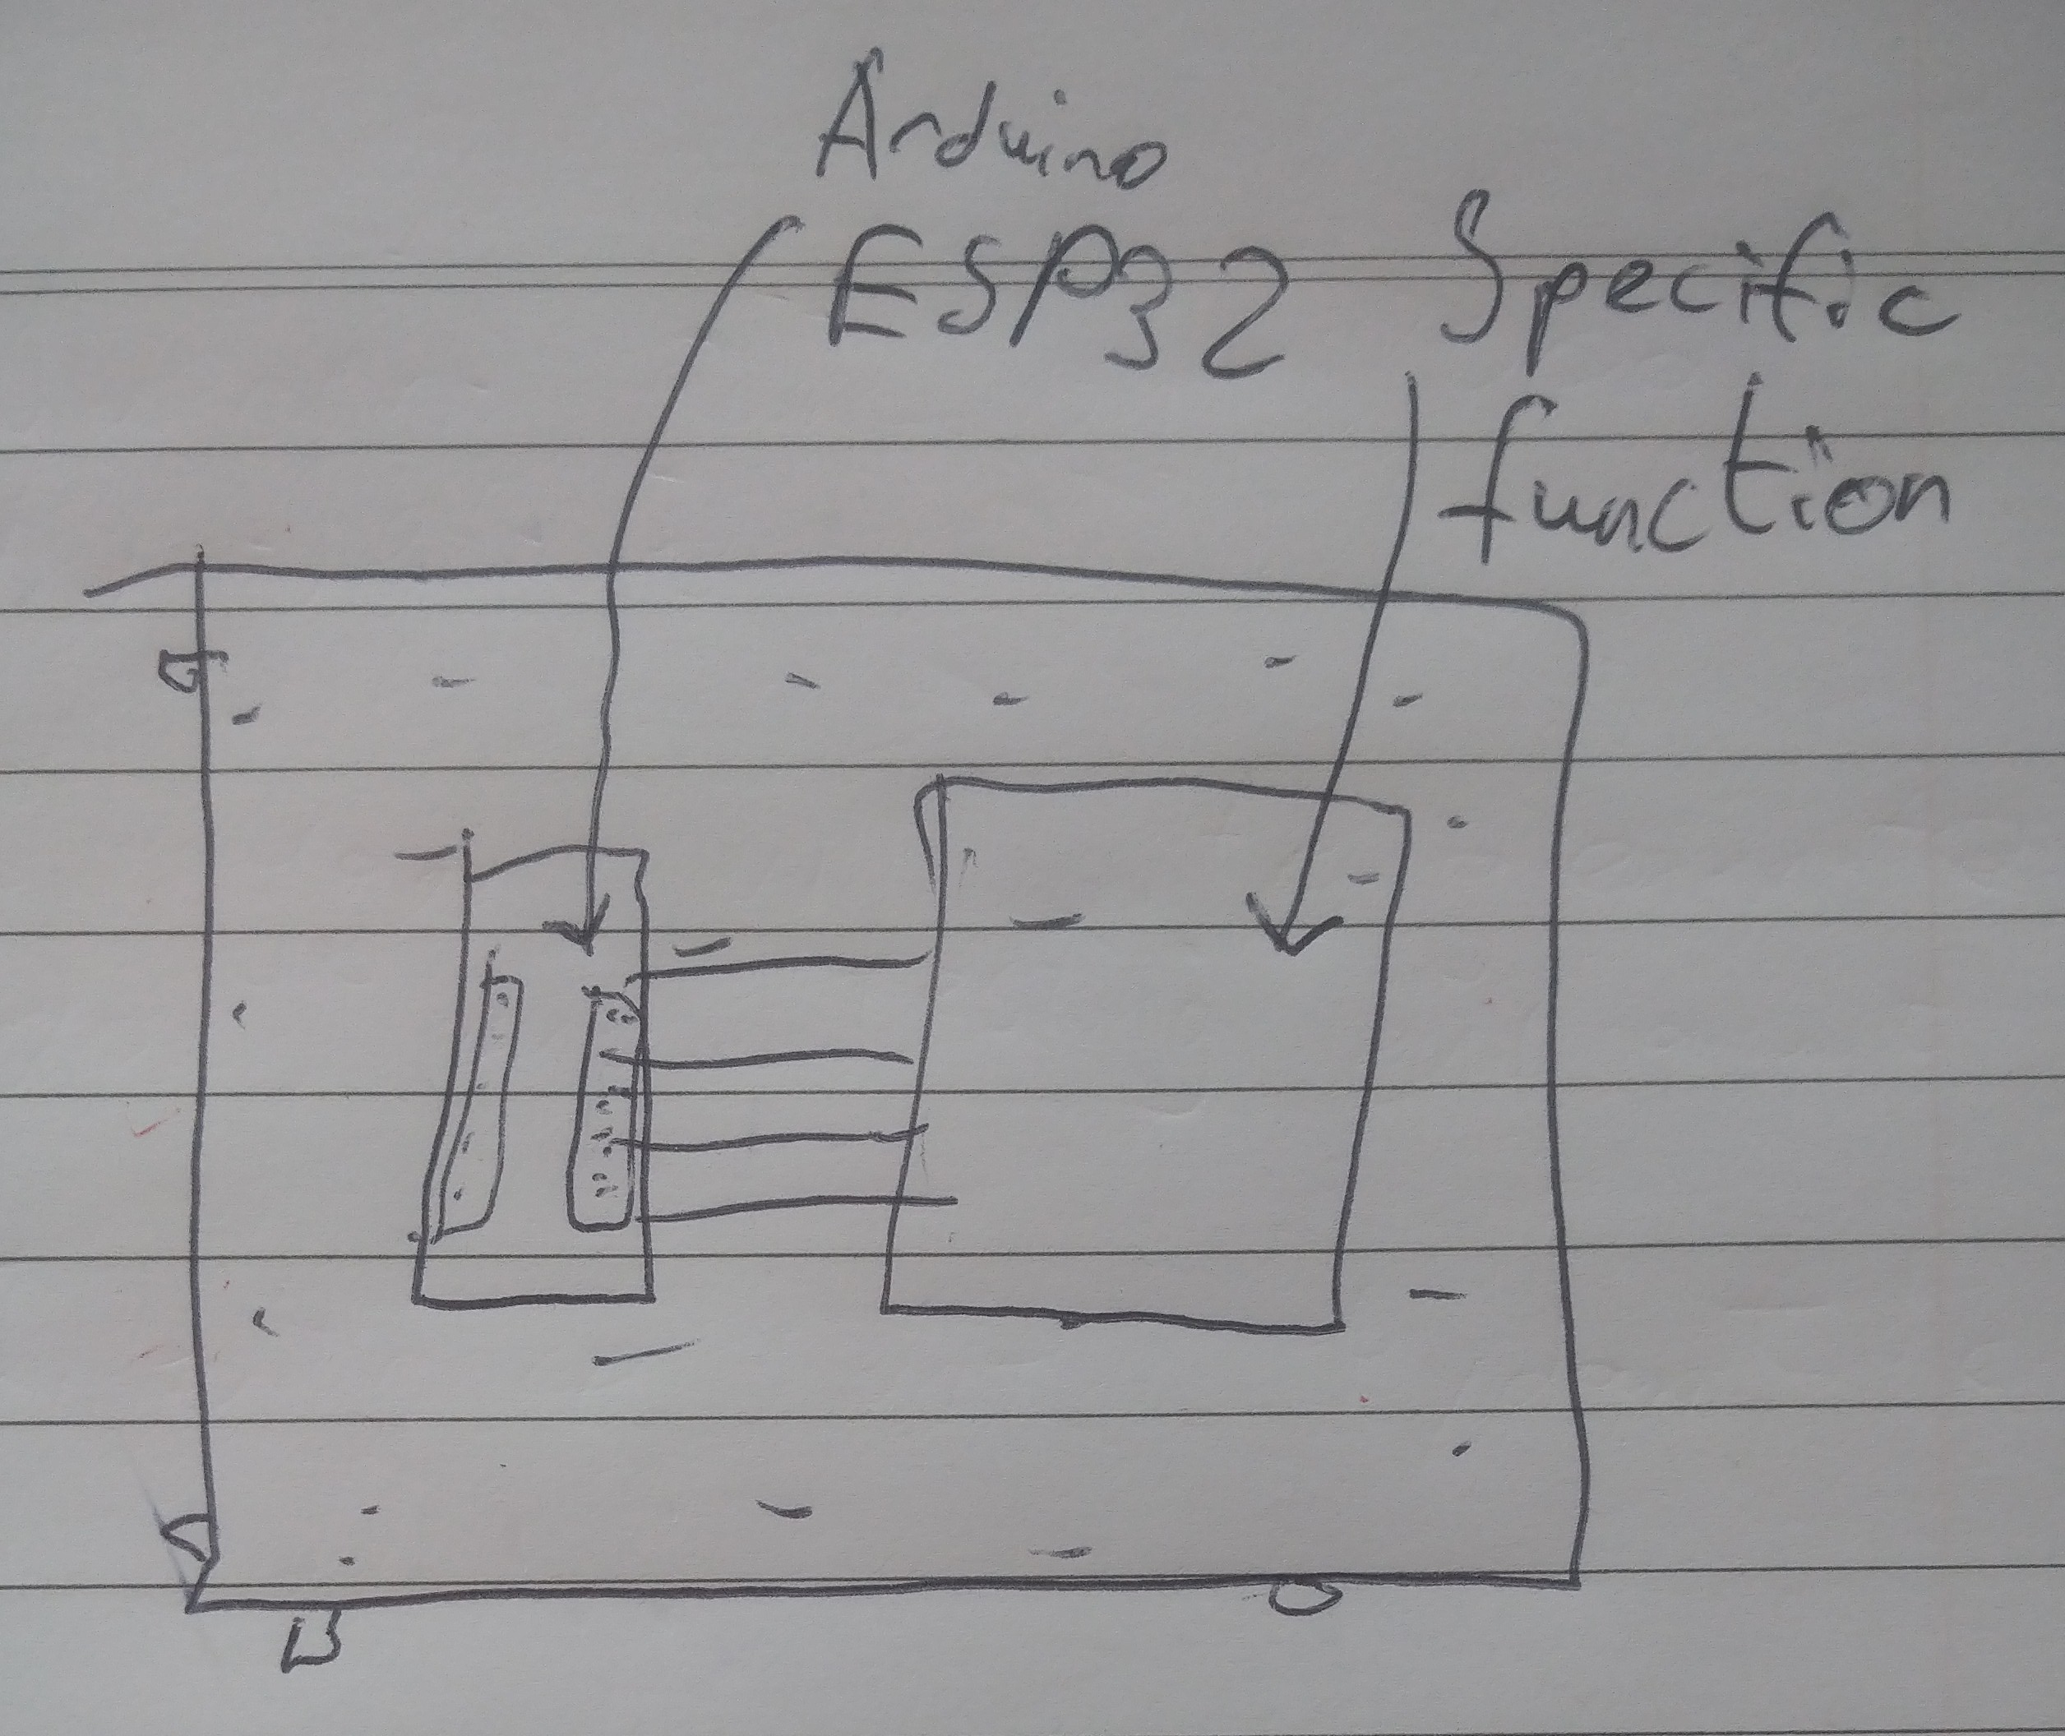

Architecture diagram

**Project plan**

* Starting a few days before today (01/10/2025) and in the coming days, I have been in communication with one of my supervisors and we have discussed the possibility of using a DHT11 as my secondary board. My main supervisor, though, has strongly advised against this decision. As for the physical design, I should be able to use the on-site milling machine that one of my supervisors is in the process of preparing.
* Today (03/10/2025), I managed to get my Altium account working and started on my architecture diagram as I have decided to take the advice of my main supervisor and use an ESP32 with an AD9833 board. As for the board design, I will start to work on that early next week.